Internal working of the HashMap

HashMap – is a part of collections framework, it implements map interface used to store key value pairs. Every key must be unique but value can be duplicates.

Properties –
- Key value pairs.
- Stores only one null key
- Every key must be unique and values can be duplicate
- Its internally use equals and hashcode function
- Stores data in the buckets and its not a thread safe

Its provide efficient speed for look up and insertion and deletion.
Summary Table
Operation | HashMap | ArrayList | Faster Choice
Lookup by Key / Value | $O(1)$ average | $O(n)$ | HashMap
Lookup by Index | Not supported efficiently | $O(1)$ | ArrayList
Insert at the end | $O(1)$ average | $O(1)$ amortized | Tie
Insert at the middle | $O(1)$ average | $O(n)$ | HashMap
Iteration / Traversal | $O(Capacity + Size)$ | $O(n)$ | ArrayList (simpler and faster iteration)
Internal working of the HashMap : -
HashMap internally use array of buckets inside the buckets its stores nodes with hashcode addresses
Bucket of key = hashcode of key % size of map

Lets suppose there are some key value pairs of
{10-ten,21-twenty,35-thirty,46-fourty,53-fifty,69-sixty}
Like for calculation of bucket of key we have to write it as
For key – 10
Bucket = 10 % 6 – 4

21 % 6 - 3

35%6 – 5

46%6 – 4

53%6 – 5

69%6 – 3

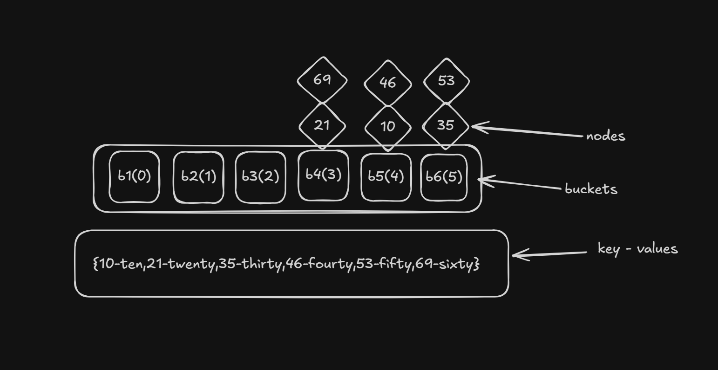

Collison - when two or more keys have same hashcode, then collision happens.
In hashmap for handling the collision we use linkedlilst and redblack tree based on these below conditions.
condition is

If(64 node on bucket > 8){
if ( treethreshold > 64){
convert -> linkedlist list to red black tree
}
else{
increase the size of buckets
}
}
this is how the collision get handled.
Load factor – default load factor of the hashmap is 0.75
Means if the default capacity of the hashmap is 16.
And if the size will increase till 12 or greater then then the capacity of the hashmap will increase to 32. For the maintaince of the time efficiency and space efficiency.

1. Capacity
- Definition: Capacity is the total number of buckets (slots) currently allocated in the underlying array of the HashMap.

2. Size
- Definition: Size is the actual number of key-value pairs currently stored inside the

